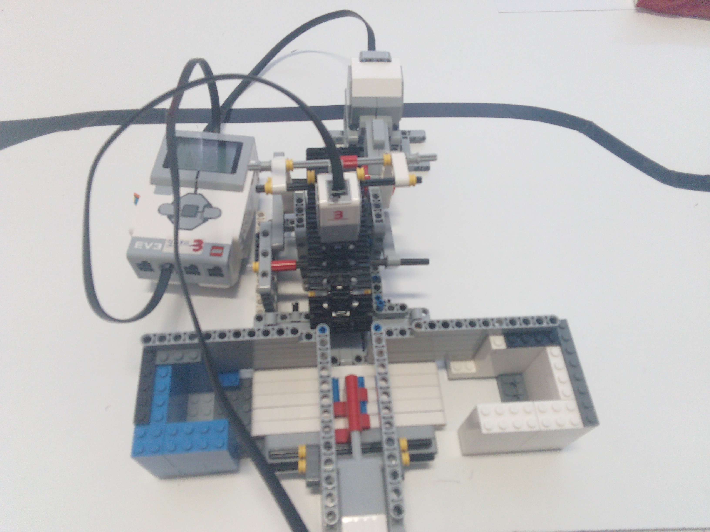

**THE TEAM:**

* ANTONIOU ORION
* KATRAKAZOS FOTIS
* SPEI MARIA
* HATZIKONSTANTI MARIALENA
* KATSOULIS MANOLIS

**MATERIALS**

* 1. A Large EV3 Motor
  2. A Medium (Servo) Motor
  3. A Colour Sensor
  4. LEGO technic bricks
  5. EV3 Smart Brick

**WHAT IS IT AND HOW DOES IT WORK**

There is a Large motor moving the belt at a certain speed to move the bricks through the colour sensor. The colour sensor reads the colour of each LEGO brick and returns its colour ID. According to this ID, the EV3 smart brick controls the movement of the sorting lever and sends the command to the sorting lever. That lever pushes the blocks on 2 boxes, one for the white bricks and a separate one for the blue bricks. The selector lever is moved by the servo motor.

